Name of Student : Raghav Mahesh Sarda PRN: 25070122235
Subject: Programming with Java Semester: III
ASSIGNMENT No : 2 Year: AY 2026-27
TITLE : Constructors in Java

Problem Statement
Develop a Java application demonstrating the use of default, parameterized, and copy constructors for object initialization and data management.

Learning Objectives
To understand and implement default, parameterized, and copy constructors for object initialization.

Program:
Student.java
// Assignment 2 - Exercise 1: Student Class
import java.util.*;
public class Student
{
String name;
int roll;

Student() // Default Constructor
{
name = "Unknown";
roll = 0;
}

Student(String name, int roll) // Parameterized Constructor
{
this.name = name;
this.roll = roll;
}

void display()
{
System.out.println("Student Name: " + name + ", Roll No: " + roll);
}

public static void main(String args[]) // Main Method
{
Scanner sc = new Scanner(System.in);

// Default Constructor
Student s1 = new Student();
System.out.print("Default Record: ");
s1.display();

// Parameterized Constructor
System.out.print("\nEnter Student Name: ");
String sname = sc.nextLine();
System.out.print("Enter Student Roll No: ");
int sroll = sc.nextInt();
sc.close();

Student s2 = new Student(sname, sroll);
System.out.print("Parameterized Record: ");
s2.display();
}
}

Mobile.java
// Assignment 2 - Exercise 2: Mobile Phone Inventory System
import java.util.*;

public class Mobile
{
String brand;
double price;

Mobile(String brand, double price) // Parameterized Constructor
{
this.brand = brand;
this.price = price;
}

Mobile(Mobile m) // Copy Constructor
{
this.brand = m.brand;
this.price = m.price;
}

void display()
{
System.out.println("Brand: " + brand + ", Price: $" + price);
}

public static void main(String args[]) // Main Method
{
Scanner sc = new Scanner(System.in);

System.out.print("Enter Mobile Brand: ");
String mbrand = sc.nextLine();
System.out.print("Enter Mobile Price: ");
double mprice = sc.nextDouble();
sc.close();

// Original object
Mobile m1 = new Mobile(mbrand, mprice);
System.out.print("Original Mobile Record: ");
m1.display();

// Duplicate object using Copy Constructor
Mobile m2 = new Mobile(m1);
System.out.print("Duplicate Mobile Record: ");
m2.display();
}
}

Output:
Student.java
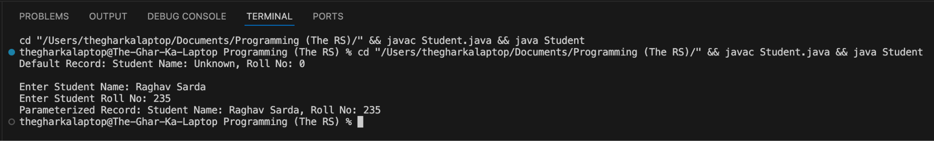
Mobile.java
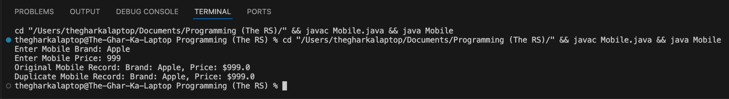

Conclusion:
In this assignment, the concepts of object-oriented data initialization using default, parameterized, and copy constructors were successfully implemented and verified. Default constructors provided reliable fallback values, parameterized constructors allowed dynamic object creation with user input, and copy constructors enabled efficient duplication of object states without altering original records.

